What Quantum Particles Can We Use for Magnetic Resonance? Quantum Spins and Nuclei

Quantum Spins and Nuclei

Table of Contents

*Expected Learning Outcomes* 2

(Optional) Introductory Activity 4

Background Information 4

Class-Wide Discussion 4

Discovery of Quantum Spin 4

Spin Quantum Numbers 6

Spin Quantum Number 7

Exploration Activity 8

Spin Magnetic Quantum Number 9

Application Questions 9

Potential Sources for Magnetic Resonance 10

Spin-½ Particles and Their Properties 10

Guided Inquiry Questions 11

Nuclear Spin 13

Guided Inquiry Questions 15

Reflection Questions 16

Supplemental Readings 17

Cited Sources 17

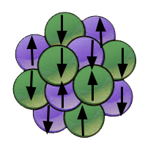

***Example Real-World Application*** Radioactive isotopes (or radioisotopes) are an important part of nuclear medicine, where radiation is used for both diagnosis and therapy. Over 40 million nuclear medicine procedures are performed each year, and demand for radioisotopes is increasing at up to 5% annually (1).

## *Expected Learning Outcomes*

*At the end of this module, students should be able to…*

1. *calculate the number of spin states and the possible values for a given spin quantum number,*
2. *determine whether a nuclear spin will be zero, integer, or half-integer*
3. *identify and explain the reasons certain isotopes are most useful for NMR*

**“The everyday fact that one’s body does not collapse spontaneously into a black hole, therefore, depends on the spin-1/2 of the electron.”**

— Malcolm Levitt, *Spin Dynamics*, pg. 9



Photo used with permission of [Katherine Morris](https://www.linkedin.com/in/katherine-morris-492045b2/) (2)

***Featured Scientist*** Katherine Morris is a molecular environmental scientist whose research focuses on the behavior of radioactive contaminants and radioactive waste produced by nuclear weapons and nuclear power. By utilizing biogeochemical, spectroscopic, and radiochemical techniques to understand the effects of long-lived radionuclides - such as strontium, technetium, uranium, neptunium, and plutonium - in engineered and natural environments, Morris is developing state-of-the-art approaches to effectively and safely dispose of radioactive waste and contain radioactive contaminants.

"A lot of our work has been quite fundamental… [it’s] really exciting for us…"  
- Katherine Morris, [Physics World Podcast](https://physicsworld.com/a/nuclear-waste-how-environmental-radiochemistry-is-improving-storage-and-site-remediation/))

# (Optional) Introductory Activity

See handout: [Introduction to the Elementary Particles Activity](https://docs.google.com/document/d/1jDdupvcN2W2xX8xYA70RyJ1nse8jRLOqynX2HeDbKbs/edit?usp=drive_link)

# Background Information

Magnetic resonance experiments depend on the interactions between **quantum spins** and magnetic fields. Here we will introduce quantum spin, explore some of the properties of the spin-1/2 particles that we will primarily be working with, and ultimately determine what particles and nuclei are commonly used in magnetic resonance experiments.

## Class-Wide Discussion

* How many elementary particles can you name?
* What particles make up an atom?
* What do you know (if anything!) about quantum spin?

# Discovery of Quantum Spin

In the early twentieth century, physics was undergoing a quantum revolution as more and more of the rules of the quantum world were being discovered. Among these many discoveries was the **quantization** of physical properties (like the energy levels of an atom). One of the most famous experiments was performed by Otto Stern and Walther Gerlach in 1922. In this experiment Stern and Gerlach aimed to explore the underlying intrinsic **magnetic moment**, , that allowed electrically neutral atoms to interact with a magnetic field. A beam of electrically neutral silver atoms were sent through an inhomogeneous magnetic field (where the strength and direction of the field varied over space) and the spatial deflection of the atomic beam was measured by observing where the atoms ended up on a screen after passing through the magnetic field.

**quantum spin** - a property of quantum particles that has many mathematical similarities to macroscopic spinning objects but also has unique quantum properties not observed in the macroscopic realm

**quantization** - mapping an infinite, continuous set of values into discrete values

**magnetic moment** - also known as magnetic dipole moment or magnetic dipole; the magnetic strength and orientation of a magnet or other object that produces a magnetic field

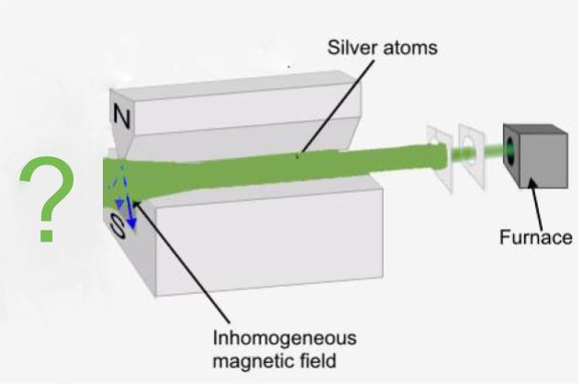

Image modified from source (3).

**Before viewing the video below, consider the following questions:**

* If there is **no** intrinsic magnetic moment that allows electrically neutral atoms to interact with a magnetic field, what would you expect to see on the screen?
* If there **is** an intrinsic magnetic moment that allows electrically neutral atoms to interact with a magnetic field **and** the atoms in the atomic beam have random orientations of that magnetic moment with respect to the magnetic field, what would you expect to see on the screen?

[**Stern-Gerlach Experiment Video Link**](https://en.wikipedia.org/wiki/File:Quantum_spin_and_the_Stern-Gerlach_experiment.ogv)

Jubobroff, [CC BY-SA 3.0](https://creativecommons.org/licenses/by-sa/3.0), via Wikimedia Commons. You can find the video and more information on the [file information page](https://commons.wikimedia.org/wiki/File:Quantum_spin_and_the_Stern-Gerlach_experiment.ogv).

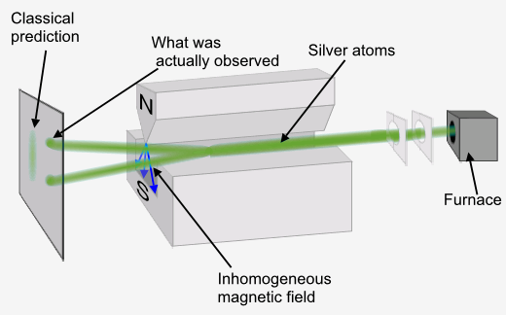

Image modified from source (3).

***FURTHER STUDY:*** To learn more about the fascinating story behind the Stern-Gerlach experiment and how it made physicists believe quantum mechanics, despite the physics theory interpretation initially being wrong, see ["How the Stern–Gerlach experiment made physicists believe in quantum mechanics".](https://physicsworld.com/a/how-the-stern-gerlach-experiment-made-physicists-believe-in-quantum-mechanics/)

This experiment provided proof that yet another physical property of the atoms was quantized, and that this property must have an intrinsic magnetic moment that allowed electrically neutral atoms to interact with a magnetic field. Scientists settled upon giving this physical property the name of ‘spin angular momentum’, - often referred to as ‘spin’, for short. This name refers to an intrinsic angular momentum of the quantum particles and obeys similar mathematical equations to the `orbital angular momentum’, , that had already been observed in atoms. (Check out the ***FURTHER STUDY*** in the margin for more details on the history behind the discovery of spin.) The Stern-Gerlach apparatus became the primary tool to investigate these quantum spin properties early on - until magnetic resonance techniques were developed.

The roles that magnetic moment and angular momentum plays in quantum spin will be further explored in another module. For now, we will go over the properties of spin that will help us determine which quantum particles can be used for magnetic resonance.

# Spin Quantum Numbers

**elementary particles** - subatomic particles that make up all known matter and cannot be divided any further into constituent parts

**bosons** - particles with integer spin; like to be buddies (i.e. bosons are happy to all crowd into the same quantum state together)

**fermions** - particles with half-integer spin; like to be frenemies (i.e. two fermions cannot share the same quantum state, but tend to pair up with a fermion with opposite spin)

The quantum spin of a particle, commonly denoted by the spin quantum number , is one of the few physical characteristics that uniquely identify an **elementary particle** - along with other information like mass and electric charge. A particle that has different spin - even if all other physical characteristics are the same - can have very different quantum mechanical behavior. Every particle has an associated spin quantum number that is either an integer or half-integer. The set of particles with integer spin are called **bosons** and the set of particles with half-integer spin are called **fermions**.

## Spin Quantum Number

Commonly denoted by , which is a positive, dimensionless number. Particles can either have an integer spin (i.e. ) or a half-integer spin (i.e. )

The Stern-Gerlach apparatus also demonstrates how to separate out different spin states of a quantum system - by putting a quantum spin in an external magnetic field. Interacting with the external magnetic field causes the different quantum spin states to have distinct energy levels, this is known as the **Zeeman effect**. The energy separation of these spin states is directly proportional to the strength of the applied magnetic field, . These distinct spin states are indexed by the spin magnetic quantum number, , and this quantum number can be negative or positive.

**Zeeman effect** - the effect of splitting of quantum energy levels in the presence of a magnetic field

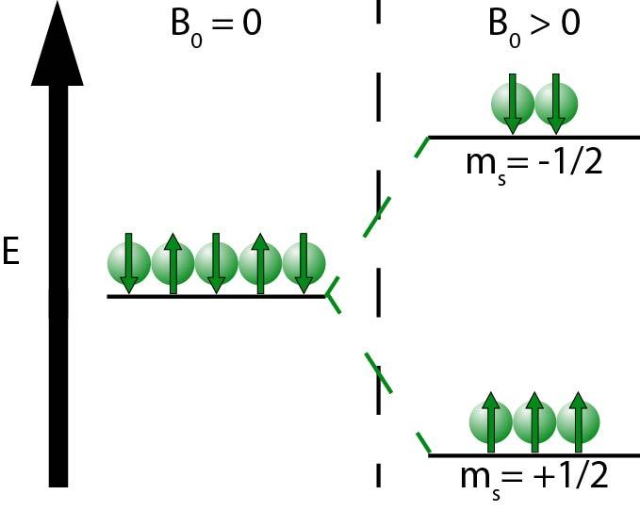

ScientistHP, [CC BY-SA 4.0](https://creativecommons.org/licenses/by-sa/4.0) via Wikimedia Commons. You can find more information on the [file information page](https://commons.wikimedia.org/wiki/File:Zeeman_splitting.jpg).

## Exploration Activity

**If we know the spin, how can we determine the number of spin states and the allowed values?**

Look carefully at the table below, and try to come up with answers to the following questions with a partner.

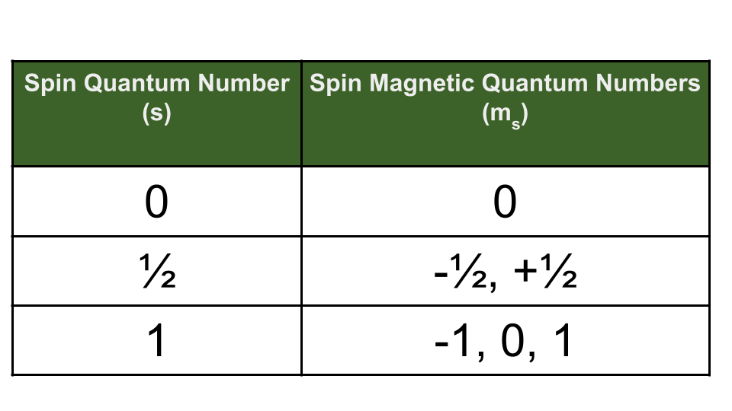

* Explore the pattern between and the allowed values. Can you come up with a rule you can follow to determine the different allowed values for a given value?
* Count up the number of values (this would equal the number of spin states) for each example in the table. Can you come up with a simple equation that would give you the number of spin states for a given value?

**Complete this activity before moving ahead where we will share the rules physicists developed to make sense of spin and spin magnetic quantum numbers!**

## Spin Magnetic Quantum Number

Commonly denoted by , which is a dimensionless number that goes from to in increments of 1.

The number of spin states can be calculated using the spin quantum number of the particle, :

For example, if then there would be 3 possible spin states, with .

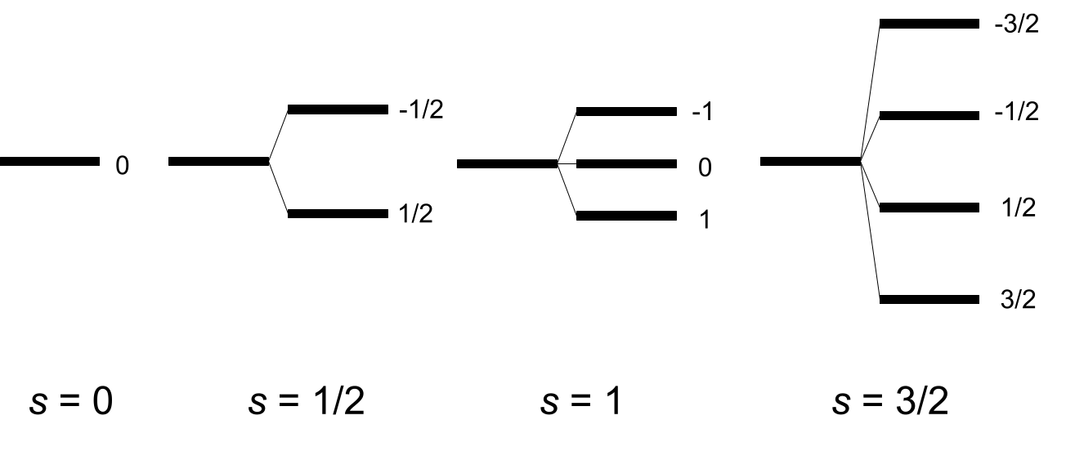

## Application Questions

1. How many different allowed spin states does a spin-2 particle have? What are the values for these states?
2. How many different allowed spin states does a spin-3/2 particle have? What are the values for these states?
3. Quantum particles that behave effectively as spin-zero particles () are sometimes said to occupy a singlet state and spin-1 particles () are sometimes said to occupy a triplet state. What do you think the reasoning is behind those names?
4. Given the observations made in the Stern-Gerlach experiment shown above, what would be the effective spin quantum number of the neutral silver atoms? How did you come to that conclusion?

# Potential Sources for Magnetic Resonance

The most relevant quantum particles in our work will be the main components of the atom: **electrons**, **protons**, and **neutrons**. Conveniently, all three have and are called spin-1/2 particles.

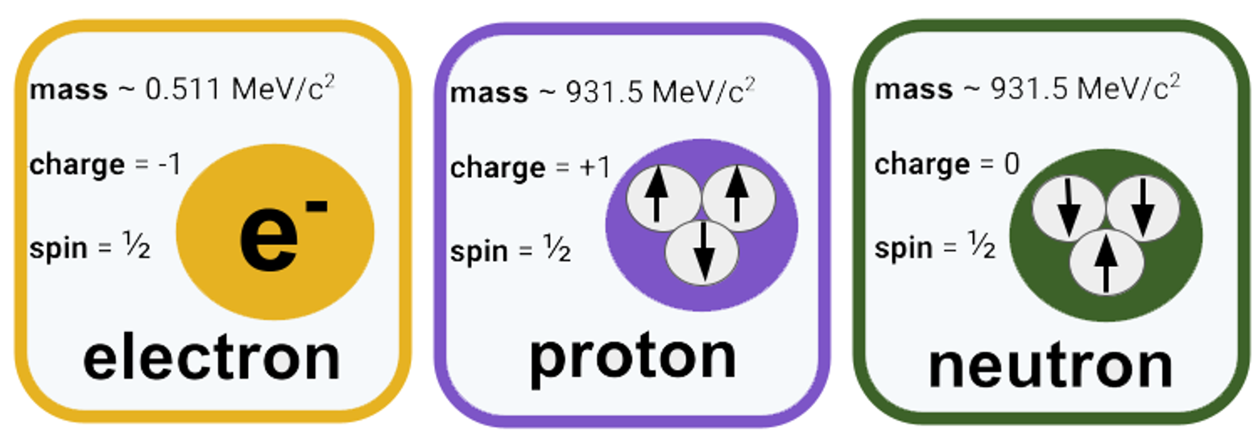

## Spin-½ Particles and Their Properties

For spin-1/2 particles (), there will be two distinct spin states: spin-up ( and typically represented by ) and spin-down ( and typically represented by ).

**Pauli exclusion principle** - fermions with the same quantum numbers are forbidden from sharing the same quantum state

**Aufbau principle** - (auf-: up in german and bau: building in german) electrons fill atomic orbitals starting with lowest energies and then building up

**Hund's rule** - the lowest energy atomic state is the one that maximizes the total spin quantum number for the electrons in the open subshell

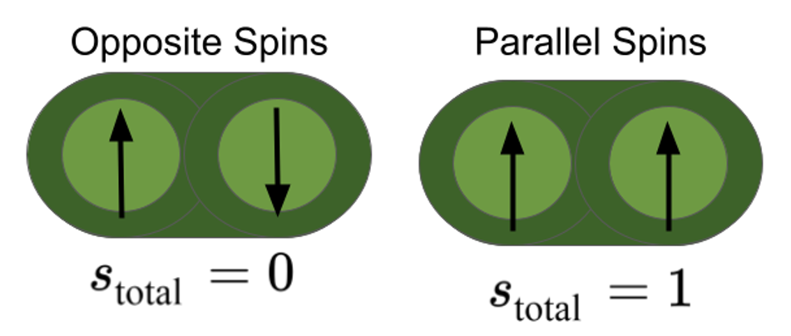

To find the *total spin* of a combination of multiple spin-1/2 particles, only spins with the same orientation can add together to give a non-zero total spin, whereas pairs of one spin-up and one spin-down contribute zero to the total spin.

As fermions, spin-1/2 particles are excluded from sharing identical quantum states ([**Pauli exclusion principle**](https://en.wikipedia.org/wiki/Pauli_exclusion_principle).) When fermions are put together (like electrons in atomic orbitals or the protons and neutrons inside the atomic nucleus) they fill up available quantum states by pairing up (spin-up with a spin-down so total contribution to overall spin is zero) before proceeding to the next energy level ([**aufbau principle**](https://en.wikipedia.org/wiki/Aufbau_principle)).

One often encounters the aufbau principle in addition to **Hund’s rule** when looking at how spin-1/2 electrons fill atomic orbitals. For example, all these principles play a role in determining that the eight electrons in the lowest energy atomic state of oxygen is 1s 2s 2p and the electrons fill the orbitals as depicted in the figure below.

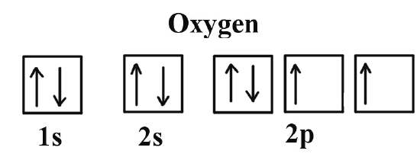

LibreTexts Chemistry, [CC BY-NC-SA 4.0](https://creativecommons.org/licenses/by-sa/4) (4)

The quantum behavior of spin-1/2 particles explains the majority of atomic and molecular structure of matter, so they are the most studied and commonly used quantum spins in experiments.

## Guided Inquiry Questions

1. Use the Pauli exclusion principle, Aufbau principle, and Hund’s rule to give the electron configuration of the six electrons of a carbon atom in its lowest energy atomic state.
2. Protons and neutrons are each made up of three quarks which each carry spin-1/2. Use the information provided above about finding the total spin of multiple spin-1/2 particles to explain why the three spin-1/2 quarks add together to give a total spin of 1/2 for both protons and neutrons.

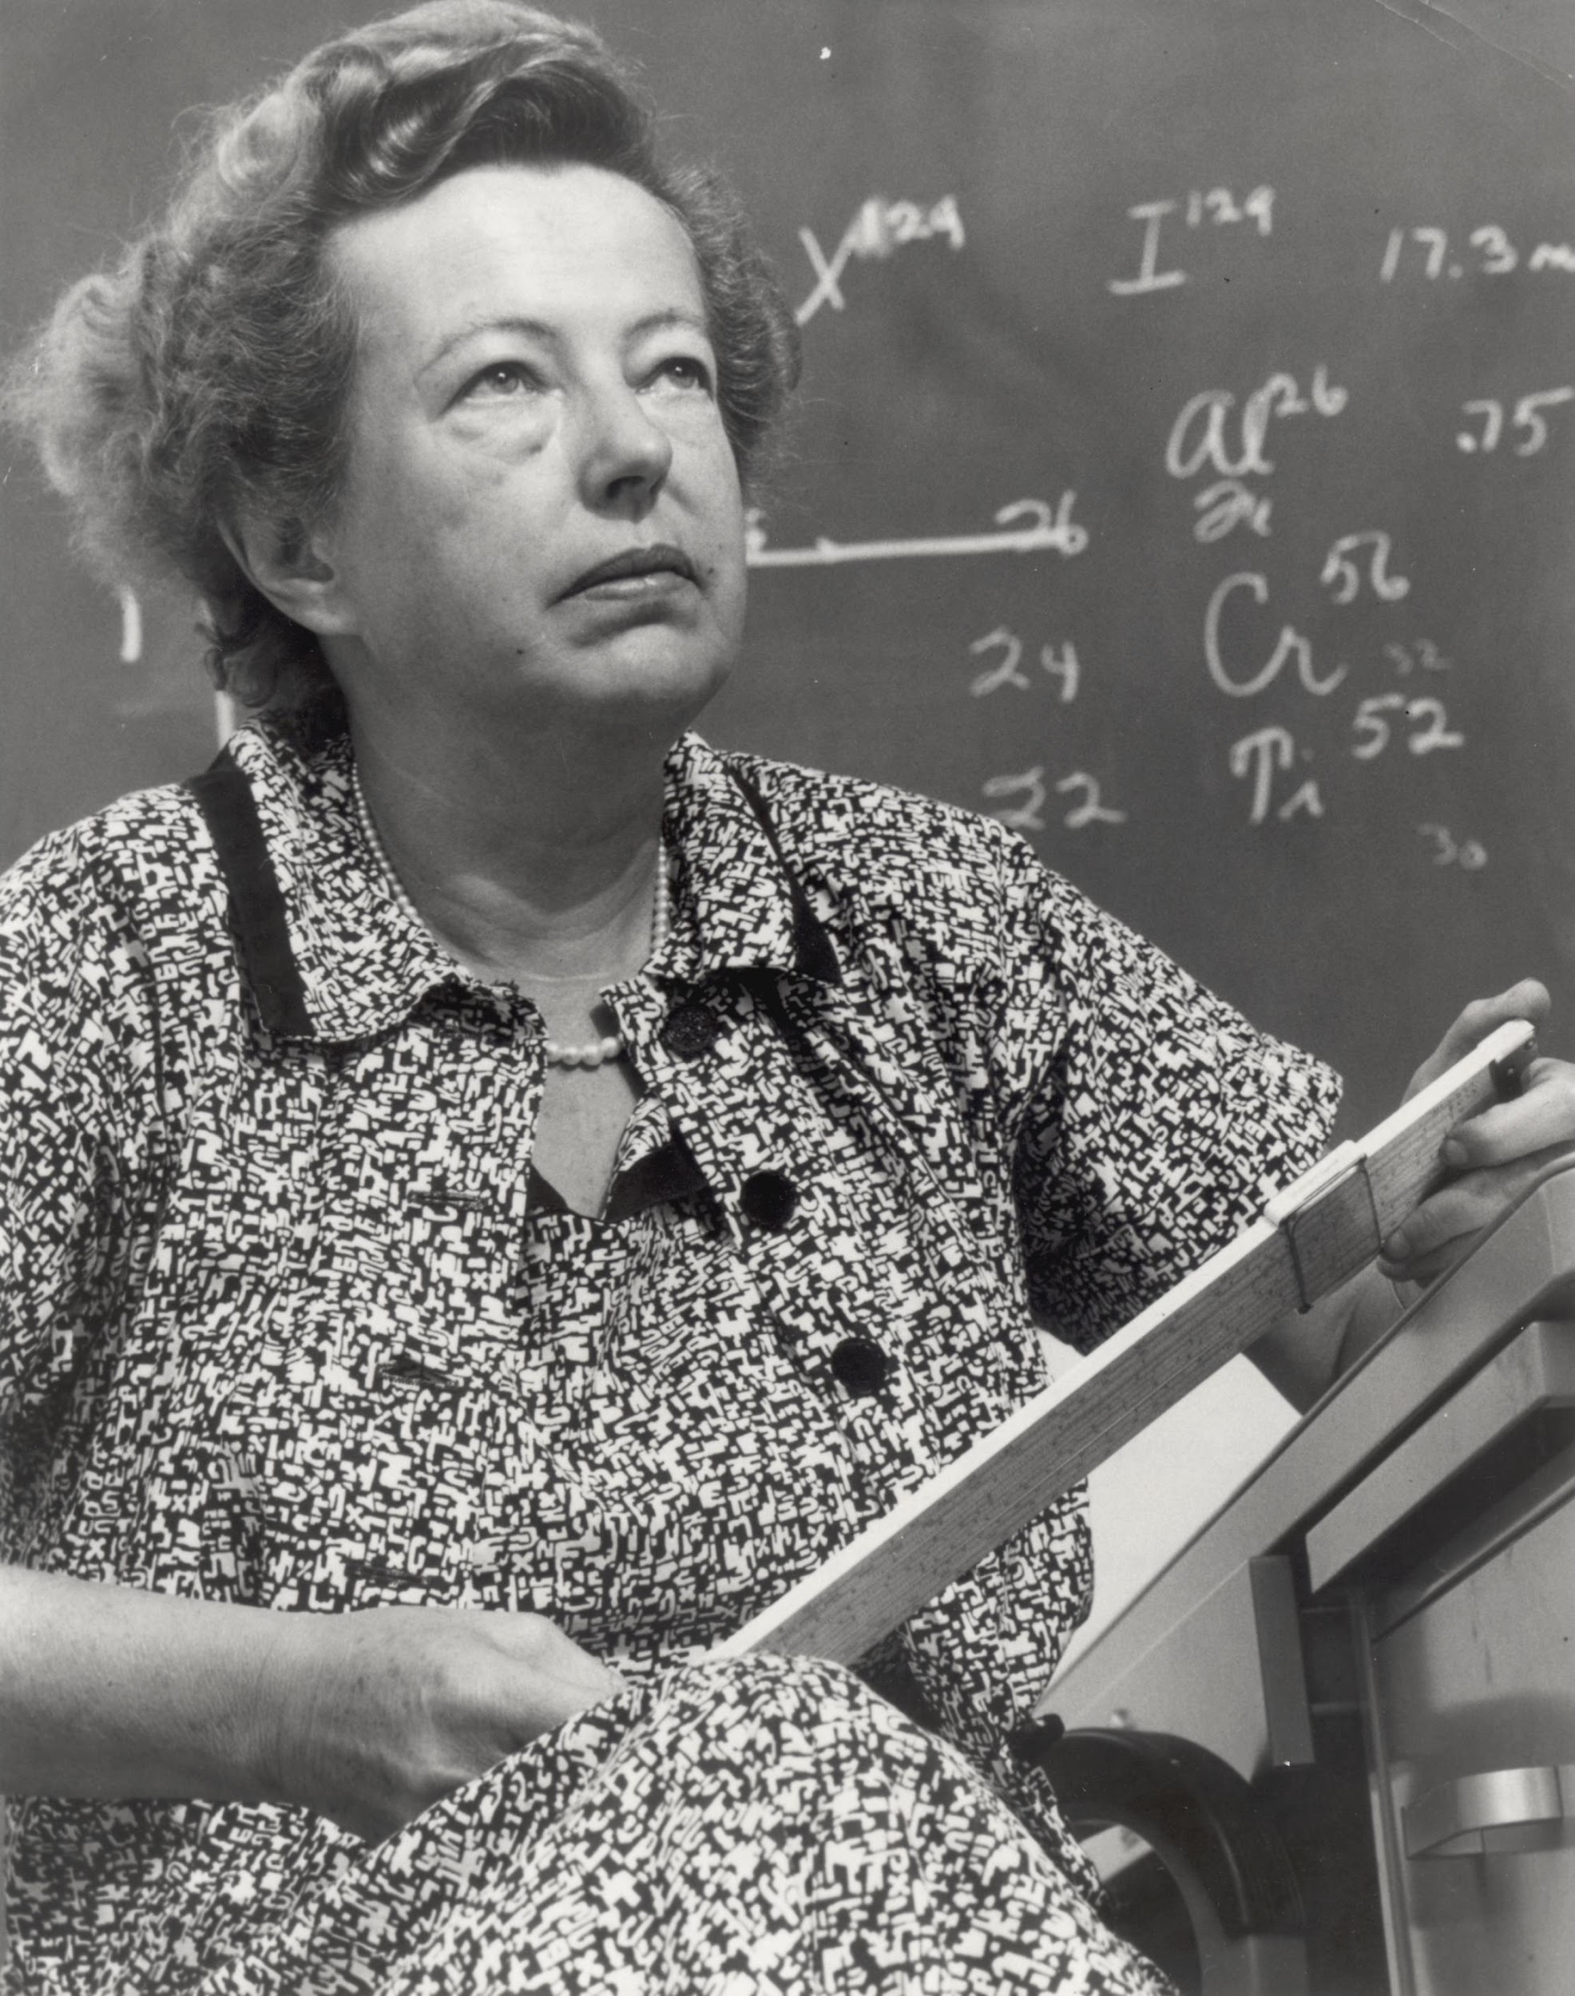

Public Domain, Image source (5)

**Maria Goeppert-Mayer** - a Physics Nobel Prize winner in 1963 and the second woman ever to receive a Physics Nobel Prize, after Marie Curie. She developed the nuclear shell model - a theoretical model that helped explain the arrangement of protons and neutrons within the atomic nucleus - and also predicted two-photon absorption - a phenomenon widely used in optics today.

"Winning the prize wasn't half as exciting as doing the work itself."  
- Maria Goeppert Mayer

# Nuclear Spin

For understanding NMR, we are interested in the total nuclear spin of the atomic nuclei, usually denoted by . Since both protons and neutrons contribute to the nuclear spin, we have to be explicit about what atomic **isotope** we are observing. *If you need a refresher on how to determine the number of proton and neutrons in the nucleus for a given isotope, check out the helpful figure in the margin!*

**isotope** - an isotope of a chemical element has the same atomic number (i.e. number of protons) but a different atomic mass (i.e. different number of neutrons); commonly written in the form "carbon-14" or $^{14}$C) where the number is the atomic mass of the isotope

**NMR only works for isotopes that have non-zero nuclear spin**, so to determine whether a given isotope may be a good candidate for NMR, it is helpful to follow some rules to determine the nuclear spin of the isotope.

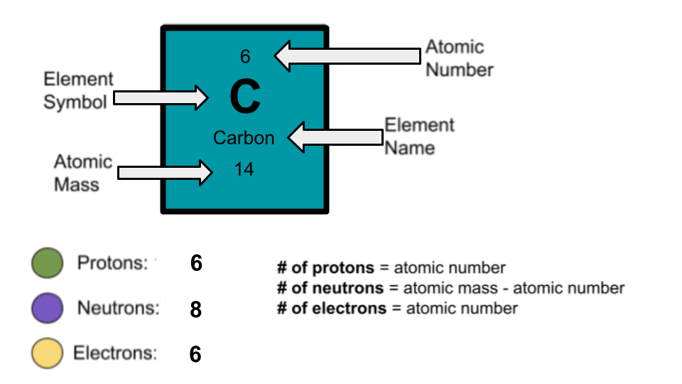

**Rules for finding the nuclear spin of a given isotope**

* If the number of neutrons **and** the number of protons are both **even**, then the nucleus has **NO** spin ().
* If the number of neutrons **plus** the number of protons is **odd**, then the nucleus has a **half-integer spin** (i.e. )
* If the number of neutrons **and** the number of protons are both **odd**, then the nucleus has an integer spin (i.e. )

By far the most NMR research is done on spin-1/2 nuclei, but technically NMR can be done on *any non-zero spin*. In this activity, you get to determine which isotopes may be the best choices for NMR.

**Check out the PhET simulation at the link below to explore some of the different isotopes in the first few rows of the periodic table.**

<https://phet.colorado.edu/sims/html/isotopes-and-atomic-mass/latest/isotopes-and-atomic-mass_en.html>

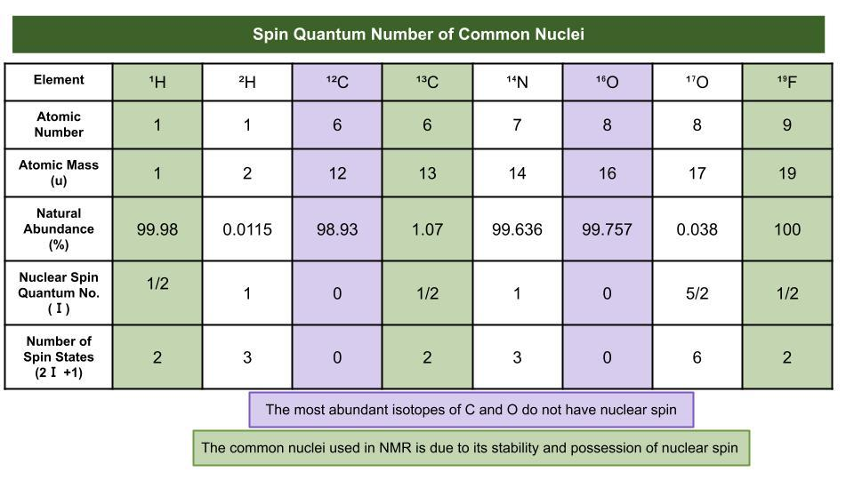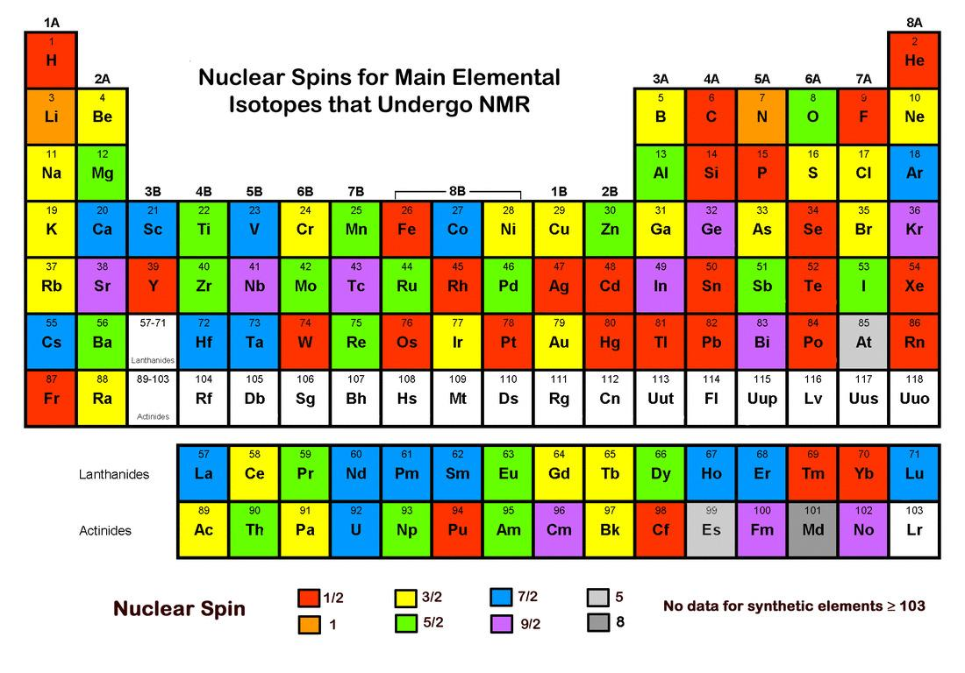

Courtesy of Allen D. Elster, MRIquestions.com (6)

## Guided Inquiry Questions

1. Using the simulation to check out different isotopes of the same element, what appears to cause a nucleus to become unstable? Why do you think it is important to use stable nuclei for NMR experiments?
2. By far the most common nucleus used for NMR is that of hydrogen-1 (essentially a single proton). What are the advantages of choosing to use this particular isotope of hydrogen for NMR?
3. Why is carbon-12 *not* a good choice for NMR, despite its large natural abundance? *Hint: use the rules above to determine the nuclear spin of this carbon isotope.* Which spin-1/2 carbon isotope do you think is then referenced in the periodic table above? *Hint: we want the isotope to be stable as well!*
4. Which spin-1/2 fluorine isotope do you think is referenced in the periodic table above? *Hint: look at different isotopes of fluorine and determine the nuclear spin using the rules above.* What are the advantages of choosing this particular isotope?

# Reflection Questions

1. Why might learning more about quantum spins be important?
2. Use what you learned about the Aufbau principle and the simplified explanation of how spin-1/2 particles get added together to provide some justification for the rules given above for finding the nuclear spin of an isotope. *Check out this YouTube video if you want a more thorough explanation of how nuclear spin gets calculated:* [*https://www.youtube.com/watch?v=pcyfvwnHddA*](https://www.youtube.com/watch?v=pcyfvwnHddA)
3. For each of the following nuclear isotopes, provide your assessment of whether they may be useful for NMR or not. (Look for non-zero nuclear spin, stability, relative abundance, etc.)
4. Phosphorus-31 (P):
5. Carbon-15 (C):
6. Helium-3 (He):
7. Silicon-29 (Si):

# Supplemental Readings

**A Chemistry Review of the Aufbau Principle, Pauli’s Principle, and Hund’s Rule:**

<https://www.youtube.com/watch?v=B3Q5a3q_5b0>

**Simulation and Explanation of the Stern-Gerlach Experiment:**

<https://www.youtube.com/watch?v=PH1FbkLVJU4>

## Cited Sources

1. <https://world-nuclear.org/information-library/non-power-nuclear-applications/radioisotopes-research/radioisotopes-in-medicine.aspx> “Radioisotopes in Medicine”
2. <https://research.manchester.ac.uk/en/persons/katherine.morris> “Katherine Morris”
3. <https://en.wikipedia.org/wiki/Stern%E2%80%93Gerlach_experiment> “Stern-Gerlach Experiment”
4. <https://chem.libretexts.org/Courses/University_of_California_Davis/UCD_Chem_002C/UCD_Chem_2C_(Larsen)/Textbook/01%3A_Chemistry_Primer/1.06%3A_Electronic_Configurations_-_Hund's_Rules> “Electronic configuration of oxygen”
5. <https://www.atomicheritage.org/profile/maria-goeppert-mayer> “Maria Goeppert-Mayer”
6. <https://mriquestions.com/predict-nuclear-spin-i.html> “Predicting Nuclear Spin I”